***Library Management System***

**1 .** CREATE DATABASE library;



**2.**

**a)**

CREATE TABLE Branch (

Branch_no INT PRIMARY KEY,

Manager_Id INT,

Branch_address VARCHAR(100),

Contact_no VARCHAR(15)

);

INSERT INTO Branch (Branch_no, Manager_Id, Branch_address, Contact_no)

VALUES

(1, 101, '123 Main St', '555-1234'),

(2, 102, '456 Elm St', '555-5678'),

(3, 103, '789 Oak St', '555-9876'),

(4, 104, '321 Pine St', '555-4321'),

(5, 105, '654 Cedar St', '555-8765');

**b)**

CREATE TABLE Employee (

Emp_Id INT PRIMARY KEY,

Emp_name VARCHAR(50),

Position VARCHAR(50),

Salary DECIMAL(10, 2),

Branch_no INT,

FOREIGN KEY (Branch_no) REFERENCES Branch(Branch_no)

);

INSERT INTO Employee (Emp_Id, Emp_name, Position, Salary, Branch_no)

VALUES

(1, 'John Smith', 'Manager', RAND() * 10000 + 50000, 1),

(2, 'Jane Doe', 'Assistant', RAND() * 5000 + 30000, 2),

(3, 'Michael Johnson', 'Librarian', RAND() * 4000 + 25000, 1),

(4, 'Emily Brown', 'Clerk', RAND() * 3000 + 20000, 3),

(5, 'Daniel Martinez', 'Assistant', RAND() * 5000 + 30000, 2);

**c)**

CREATE TABLE Books (

ISBN VARCHAR(20) PRIMARY KEY,

Book_title VARCHAR(100),

Category VARCHAR(50),

Rental_Price DECIMAL(10, 2),

Status ENUM('yes', 'no'),

Author VARCHAR(50),

Publisher VARCHAR(50)

);

INSERT INTO Books (ISBN, Book_title, Category, Rental_Price, Status, Author, Publisher)

VALUES

('978-3-16-148410-0', 'The Great Gatsby', 'Fiction', RAND() * 10 + 10, 'yes', 'F. Scott Fitzgerald', 'Scribner'),

('978-0-306-40615-7', '1984', 'Dystopian', RAND() * 8 + 8, 'yes', 'George Orwell', 'Secker & Warburg'),

('978-0-8129-7263-5', 'To Kill a Mockingbird', 'Classic', RAND() * 9 + 9, 'yes', 'Harper Lee', 'HarperCollins'),

('978-0-451-52360-4', 'The Catcher in the Rye', 'Coming-of-Age', RAND() * 7 + 7, 'yes', 'J.D. Salinger', 'Little, Brown'),

('978-1-101-93575-9', 'Pride and Prejudice', 'Romance', RAND() * 11 + 11, 'yes', 'Jane Austen', 'T. Egerton, Whitehall');

**d)**

CREATE TABLE Customer (

Customer_Id INT PRIMARY KEY,

Customer_name VARCHAR(50),

Customer_address VARCHAR(100),

Reg_date DATE

);

INSERT INTO Customer (Customer_Id, Customer_name, Customer_address, Reg_date)

VALUES

(1, 'Alice Johnson', '789 Maple Ave', DATE_SUB(CURDATE(), INTERVAL FLOOR(RAND() * 10) YEAR)),

(2, 'Bob Smith', '456 Birch St', DATE_SUB(CURDATE(), INTERVAL FLOOR(RAND() * 10) YEAR)),

(3, 'Carol Williams', '321 Cedar Ln', DATE_SUB(CURDATE(), INTERVAL FLOOR(RAND() * 10) YEAR)),

(4, 'David Brown', '987 Oak Dr', DATE_SUB(CURDATE(), INTERVAL FLOOR(RAND() * 10) YEAR)),

(5, 'Emma Garcia', '654 Pine Rd', DATE_SUB(CURDATE(), INTERVAL FLOOR(RAND() * 10) YEAR));

**e)**

CREATE TABLE IssueStatus (

Issue_Id INT PRIMARY KEY,

Issued_cust INT,

Issued_book_name VARCHAR(100),

Issue_date DATE,

Isbn_book VARCHAR(20),

FOREIGN KEY (Issued_cust) REFERENCES Customer(Customer_Id),

FOREIGN KEY (Isbn_book) REFERENCES Books(ISBN)

);

INSERT INTO IssueStatus (Issue_Id, Issued_cust, Issued_book_name, Issue_date, Isbn_book)

VALUES

(1, 1, 'The Great Gatsby', DATE_SUB(CURDATE(), INTERVAL FLOOR(RAND() * 30) DAY), '978-3-16-148410-0'),

(2, 2, '1984', DATE_SUB(CURDATE(), INTERVAL FLOOR(RAND() * 30) DAY), '978-0-306-40615-7'),

(3, 3, 'To Kill a Mockingbird', DATE_SUB(CURDATE(), INTERVAL FLOOR(RAND() * 30) DAY), '978-0-8129-7263-5'),

(4, 4, 'The Catcher in the Rye', DATE_SUB(CURDATE(), INTERVAL FLOOR(RAND() * 30) DAY), '978-0-451-52360-4'),

(5, 5, 'Pride and Prejudice', DATE_SUB(CURDATE(), INTERVAL FLOOR(RAND() * 30) DAY), '978-1-101-93575-9');

**f)**

CREATE TABLE ReturnStatus (

Return_Id INT PRIMARY KEY,

Return_cust INT,

Return_book_name VARCHAR(100),

Return_date DATE,

Isbn_book2 VARCHAR(20),

FOREIGN KEY (Return_cust) REFERENCES Customer(Customer_Id),

FOREIGN KEY (Isbn_book2) REFERENCES Books(ISBN)

);

INSERT INTO ReturnStatus (Return_Id, Return_cust, Return_book_name, Return_date, Isbn_book2)

SELECT

i.Issue_Id,

i.Issued_cust,

i.Issued_book_name,

DATE_ADD(i.Issue_date, INTERVAL FLOOR(RAND() * 15) DAY),

i.Isbn_book

FROM IssueStatus i;

**Queries**

1. **Retrieve the book title, category, and rental price of all available books.**

SELECT Book_title, Category, Rental_Price

FROM Books

WHERE Status = 'yes';

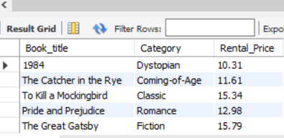

1. **List the employee names and their respective salaries in descending order of salary.**

SELECT Emp_name, Salary

FROM Employee

ORDER BY Salary DESC;

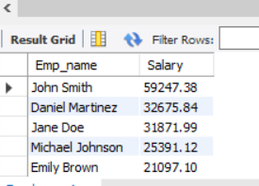

**3. Retrieve the book titles and the corresponding customers who have issued those books**

SELECT b.Book_title, c.Customer_name

FROM IssueStatus i

JOIN Books b ON i.Isbn_book = b.ISBN

JOIN Customers c ON i.Issued_cust = c.Customer_Id;

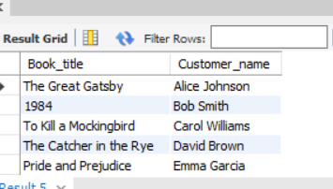

**4.** **Display the total count of books in each category.**

SELECT Category, COUNT(*) AS Total_Books

FROM Books

GROUP BY Category;

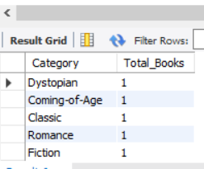

**5. Retrieve the employee names and their positions for the employees whose salaries are above Rs. 50,000.**

SELECT Emp_name, Position

FROM Employee

WHERE Salary > 50000;

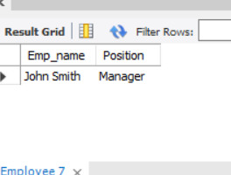

**6.** **List the customer names who registered before 2022-01-01 and have not issued any books yet.**

SELECT Customer_name

FROM Customers c

WHERE Reg_date < '2022-01-01'

AND NOT EXISTS (

SELECT 1

FROM IssueStatus i

WHERE i.Issued_cust = c.Customer_Id

);

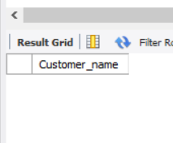

**7. Display the branch numbers and the total count of employees in each branch.**

SELECT e.Branch_no, COUNT(*) AS Total_Employees

FROM Employee e

GROUP BY e.Branch_no;

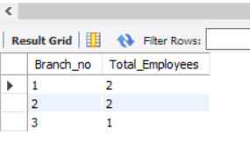

**8.** **Display the names of customers who have issued books in the month of June 2023.**

**SELECT DISTINCT c.Customer_name**

**FROM Customers c**

**JOIN IssueStatus i ON c.Customer_Id = i.Issued_cust**

**WHERE YEAR(i.Issue_date) = 2023 AND MONTH(i.Issue_date) = 6;**

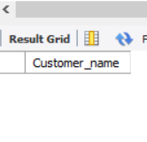

**9.** **Retrieve Book_title from the Books table containing "history".**

SELECT Book_title

FROM Books

WHERE Category LIKE '%history%';

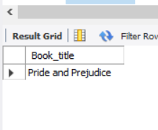

**10.** **Retrieve the branch numbers along with the count of employees for branches having more than 1 employees.**

SELECT e.Branch_no, COUNT(*) AS Total_Employees

FROM Employee e

GROUP BY e.Branch_no

HAVING COUNT(*) > 1;

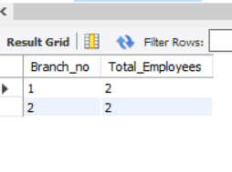

**11.** **Retrieve the names of employees who manage branches and their respective branch addresses.**

SELECT e.Emp_name, b.Branch_address

FROM Employee e

JOIN Branch b ON e.Branch_no = b.Branch_no

WHERE e.Position = 'Manager';

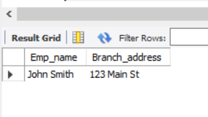

**12. Display the names of customers who have issued books with a rental price higher than Rs. 2.**

SELECT DISTINCT c.Customer_name

FROM Customers c

JOIN IssueStatus i ON c.Customer_Id = i.Issued_cust

JOIN Books b ON i.Isbn_book = b.ISBN

WHERE b.Rental_Price > 25;

